**NOTE:- To be done on paper. Only Program, Flow Chart and Cyclomatic Complexity with Test Cases to be shown (As far as I know)**

**Code to find greatest of 3 numbers:**

public class LargestNumberExample4

{

public static void main(String[] args)

{

int x = 1010, y = 170, z = 169;

if(x >= y)

{

if(x >= z)

System.out.println("The largest number is: "+x);

else

System.out.println("The largest number is: "+z);

}

else

{

if(y >= z)

System.out.println("The largest number is: "+y);

else

System.out.println("The largest number is: "+z);

}

}

}

**Control Flow Diagram:**

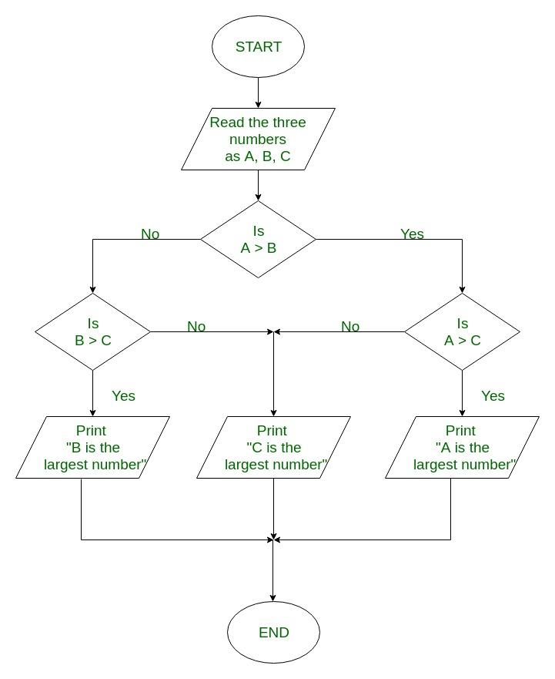

Method 1: -

● Cyclomatic Complexity that is V(G) is given as follows -

● Number of predicate nodes(P) = 3

● V(G) = P + 1 = 3 + 1 = 4

Method 2: -

● Number of Edges(E) = 11

● Number of Nodes(N) = 9

● V(G) = E – N + 2 = 11 - 9 +2 = 4

Method 3: -

● V(G) = Number of non-overlapping edges

● Number of non-overlapping edges = 4

● V(G) = 4

Successful Test Case in JUnit:

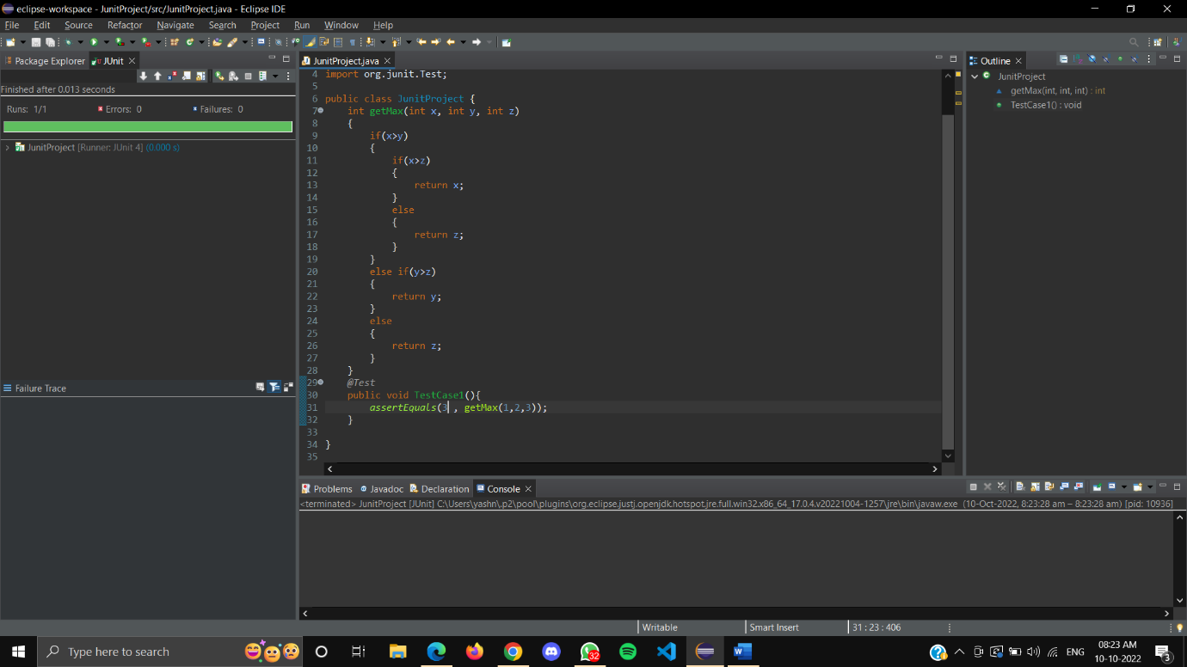

Failed Test Case in JUnit:

